**BUAN 6346 Big Data Analytics**

**(Hive – Twitter Data Analysis)**

1. What are the hashtags used and how many times each hashtag is used?

**Step 1: To import JSON file from Desktop into Hive:**

**Query :**

create table tweets_json(json string);

load data local inpath 'Desktop/Tweets.json' overwrite into table tweets_json;

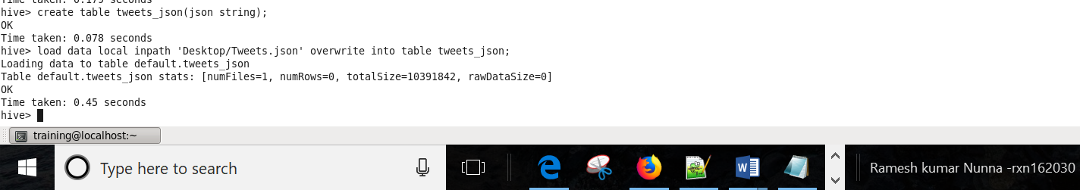

**Step 2: Reading the Json data(.text object) into tweets_text table**

**Query:**

create table tweets_text as

select get_json_object(json, '$.text') as text from tweets_json;

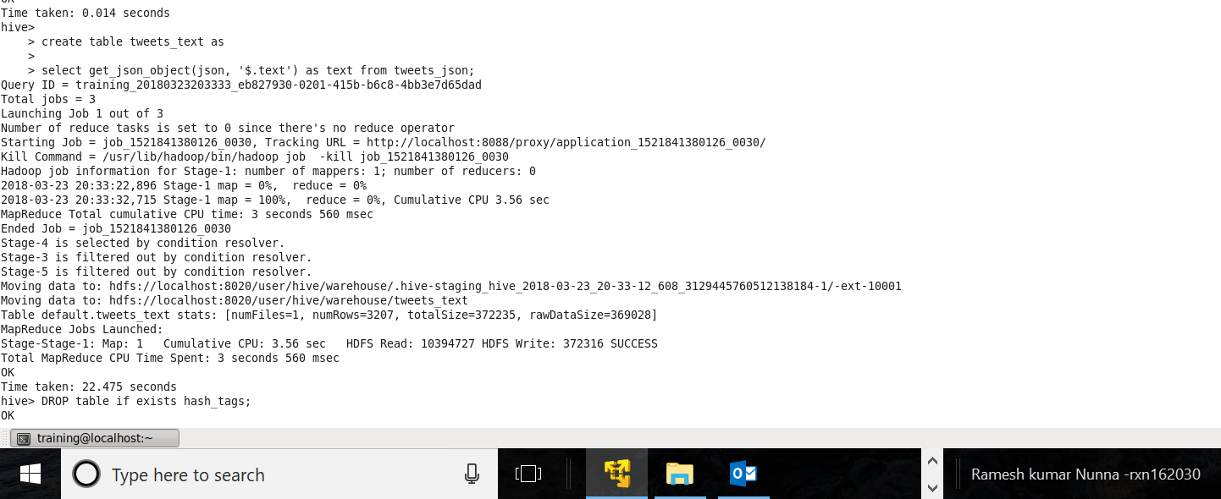

**Step 3: Splitting the text by space and filtering out the hashtags**

**Query:**

DROP table if exists hash_tags;

CREATE table hash_tags as SELECT * FROM (SELECT explode(split(text,' ')) as hashtags FROM tweets_text) as hashtags_twitter WHERE hashtags like '#%';

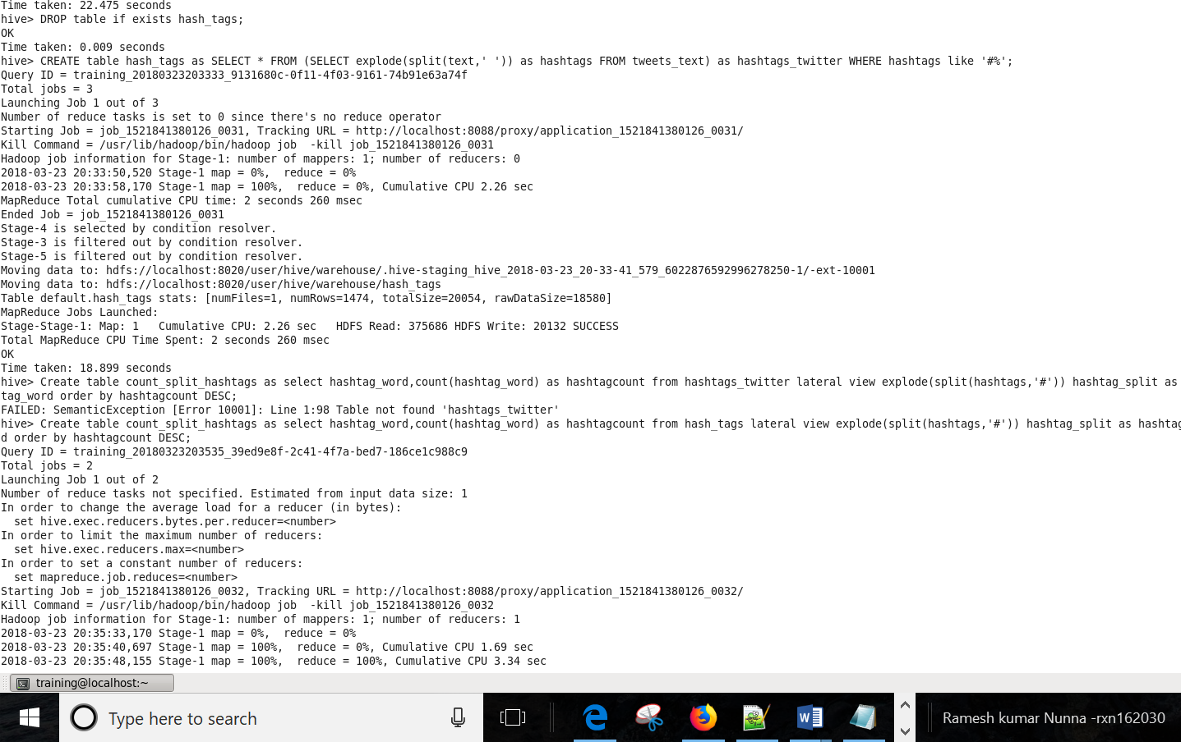

**Step 4: Again, splitting the words around # (so that continuous hashtags will get split)**

**Query:**

Create table count_split_hashtags as select hashtag_word,count(hashtag_word) as hashtagcount from hash_tags lateral view explode(split(hashtags,'#')) hashtag_split as hashtag_word where length(hashtag_word) > 0 group by hashtag_word order by hashtagcount DESC;

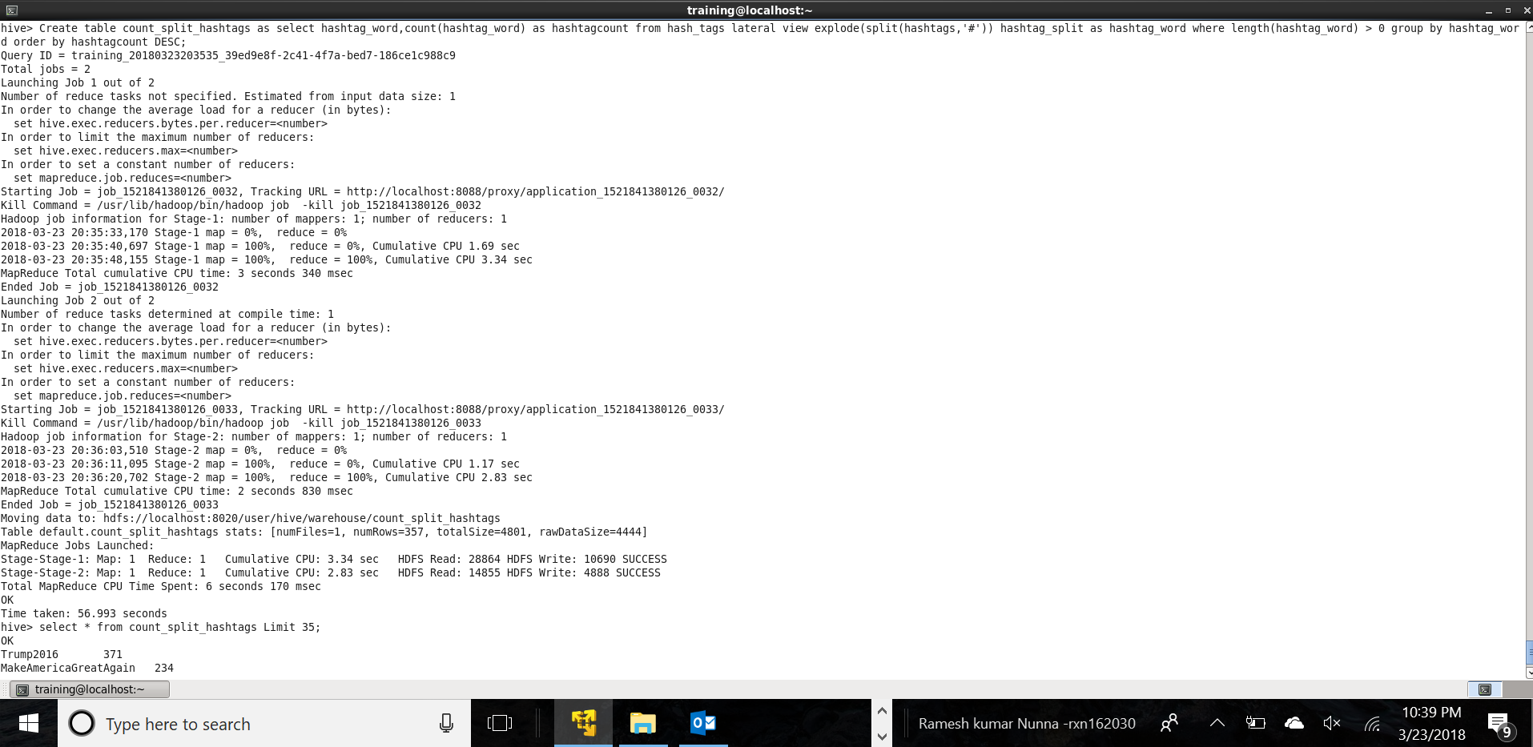

**Step 4: Showing top 35 trending hashtags from current table**

**Query:**

select * from count_split_hashtags Limit 35;

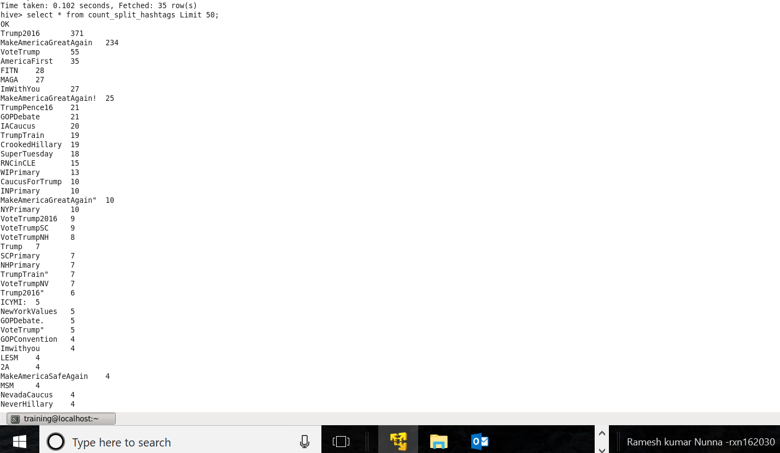

*Optimization: Assuming we should handle case, remove punctuation and extra characters from hashtags*

**Step 5: Optimizing code (Removing punctuation, extra characters and handling case)**

**Query:**

Create table count_split_hashtags_clean as select lower(REGEXP_REPLACE(hashtag_word,'[^a-zA-Z0-9]+', '')) as clean_hashtags from hash_tags lateral view explode(split(hashtags,'#')) hashtag_split as hashtag_word where length(hashtag_word) > 0

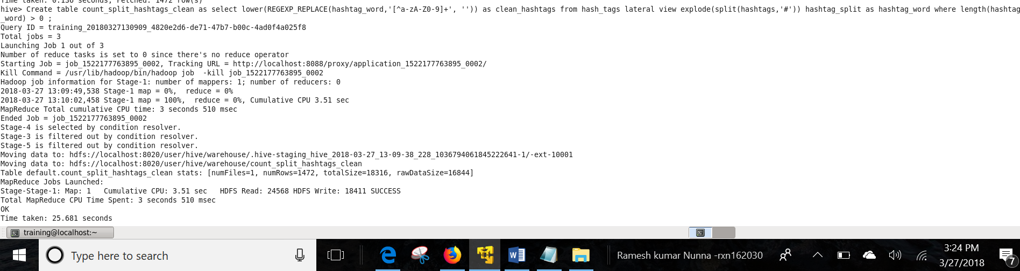

**Step 6: output**

**Query:**

select clean_hashtags , count(clean_hashtags) as count_clean_hashtags from count_split_hashtags_clean group by clean_hashtags order by count_clean_hashtags desc;

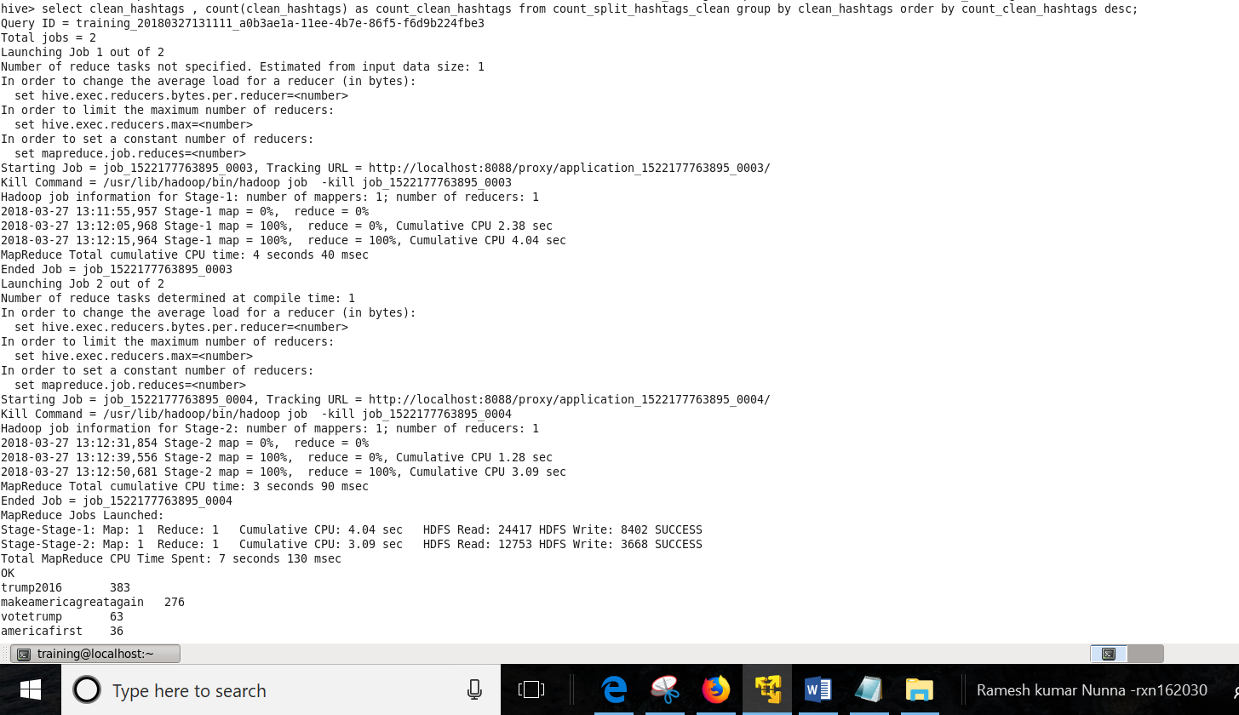

**Showing few hashtags:**

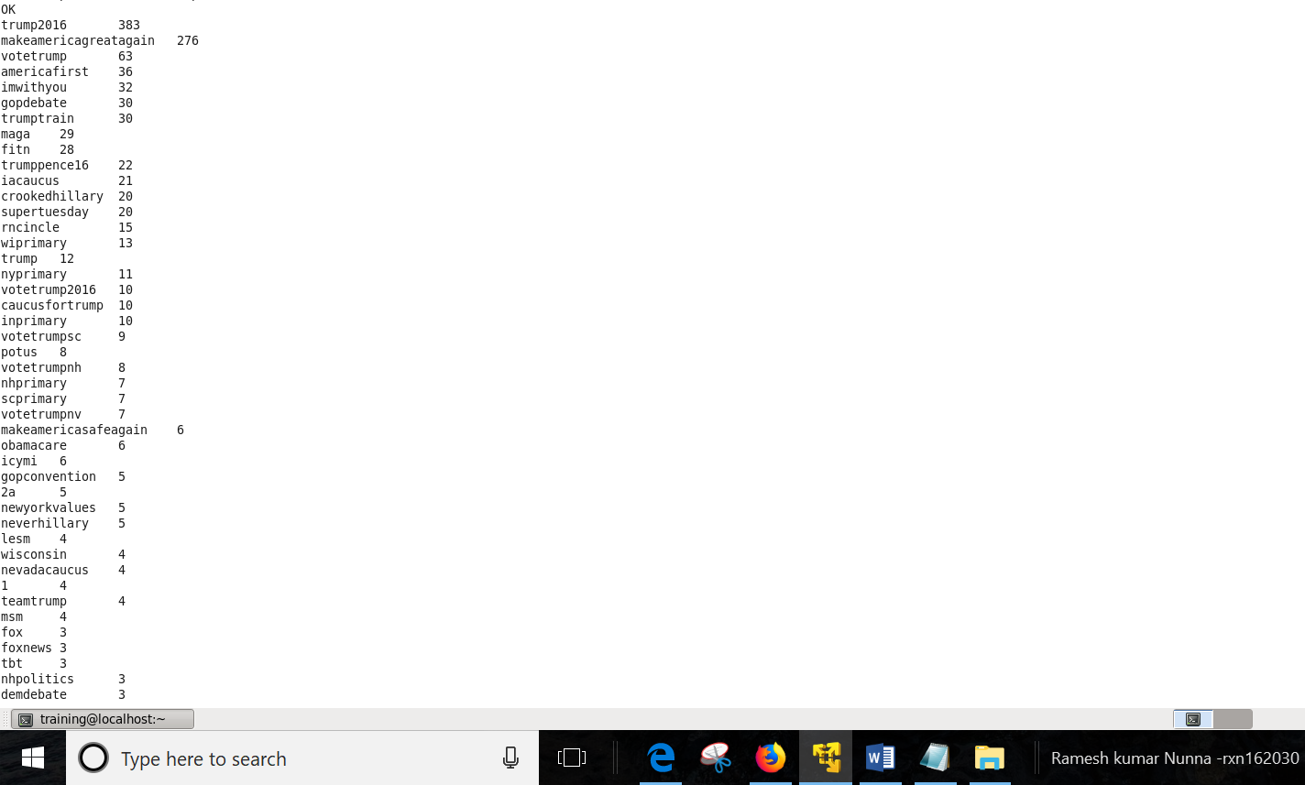

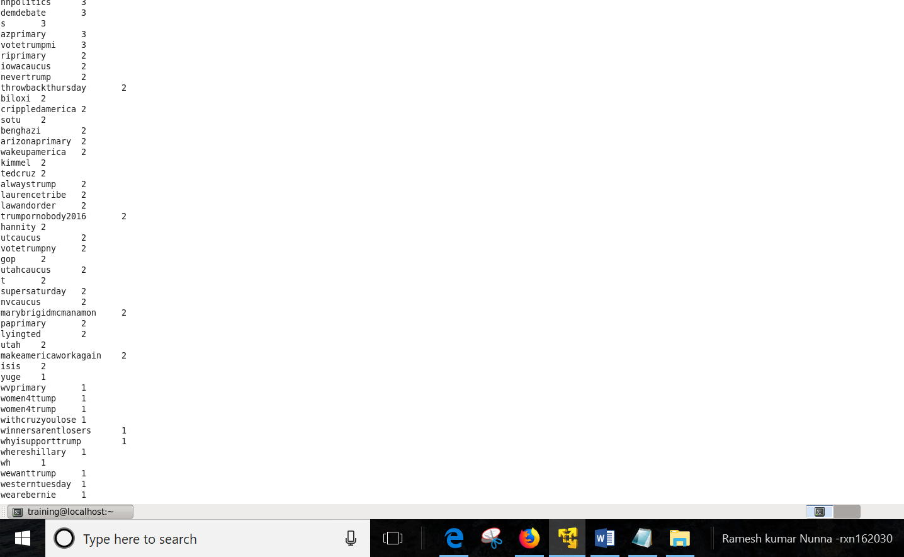

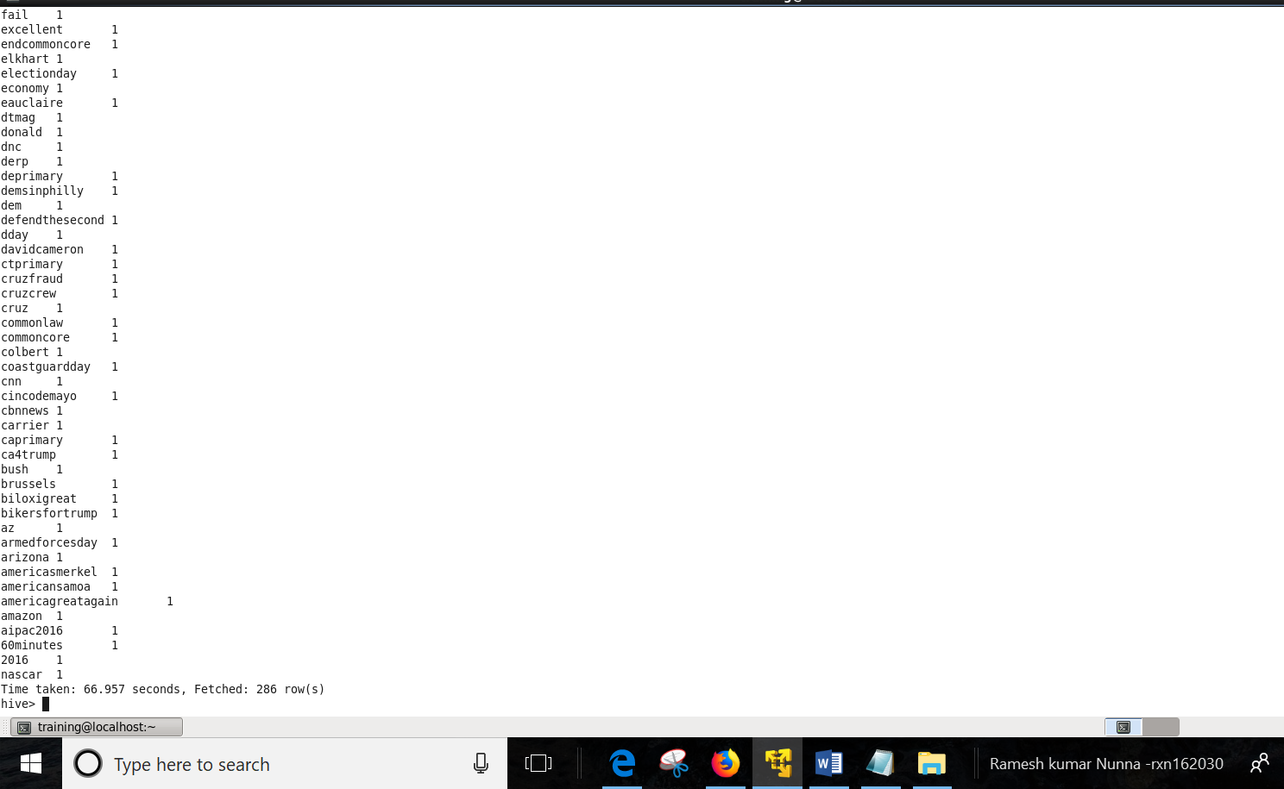

1b) Which State have the most active users and how many tweets are posted by State?

1. ***For questions 1b, 1c assuming '$.user.id' is the user tweeting and '$.user.location’ is the location of the user tweeting.***

**Assuming '$.user.location’ is the location of the user(s) tweeting**

**Step 1: Reading JSON data**

**Query:**

CREATE table active_users as

SELECT get_json_object(json, '$.user.location') as user_location, get_json_object(json, '$.retweet_count') as retweet_count FROM tweets_json;

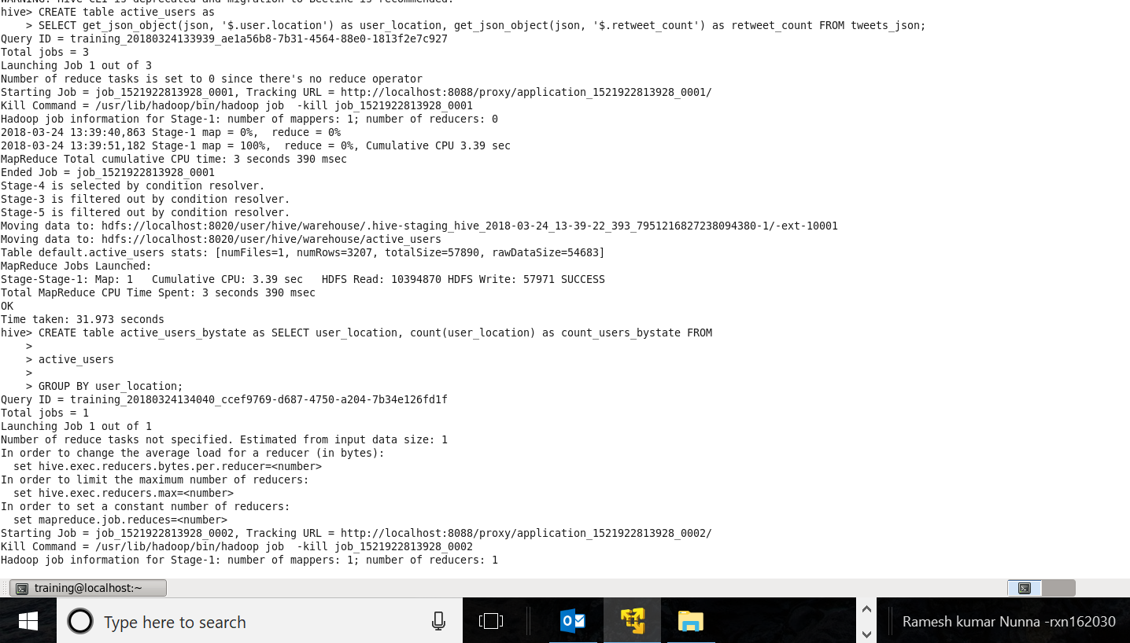

**Step 2: Aggregating users by location**

**Query:**

CREATE table active_users_bystate as SELECT user_location, count(user_location) as count_users_bystate FROM

active_users

GROUP BY user_location

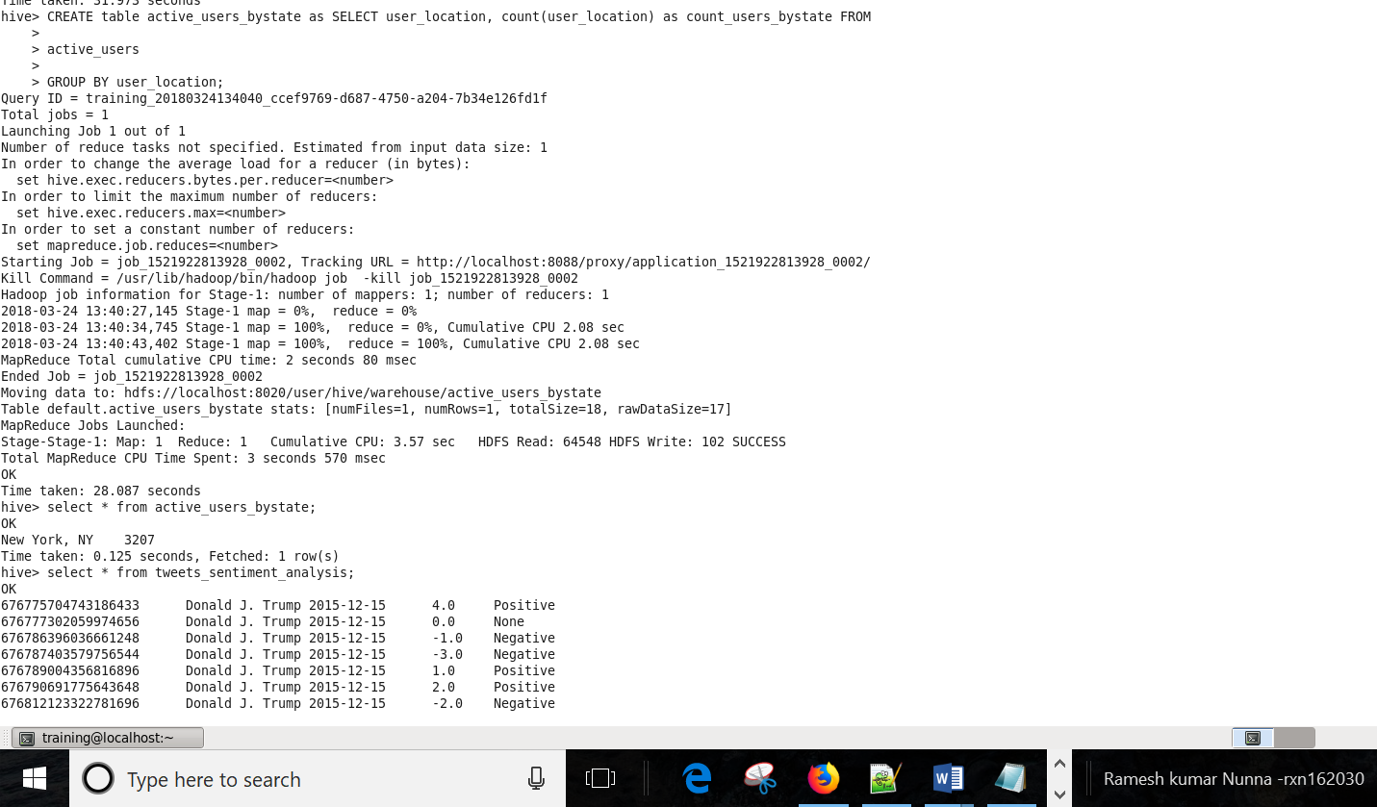

**Step 3: Output**

**Query**

Select * from active_users_bystate

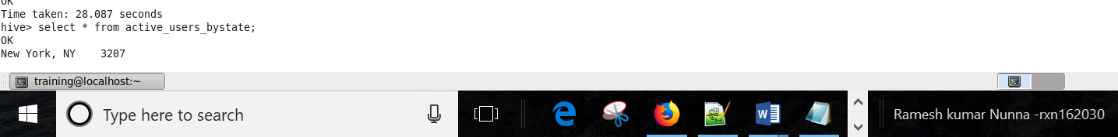

***"New York, NY" has the most active users and all the tweets 3207 are posted by that state.***

1 c) Based on the user’s followers count, who are the top ten users who have tweeted?

1. ***Assuming all the tweets are from only user(s) under json object ‘$.user.id'***

**Assuming ‘$.user.id' is the user who is tweeting**

**Step1: Reading Json data**

**Query:**

*drop table if exists Users_followers;*

*create table Users_followers as*

*select get_json_object(json, '$.user.id') as user,*

*get_json_object(json, '$.user.followers_count') as count_followers*

*from tweets_json;*

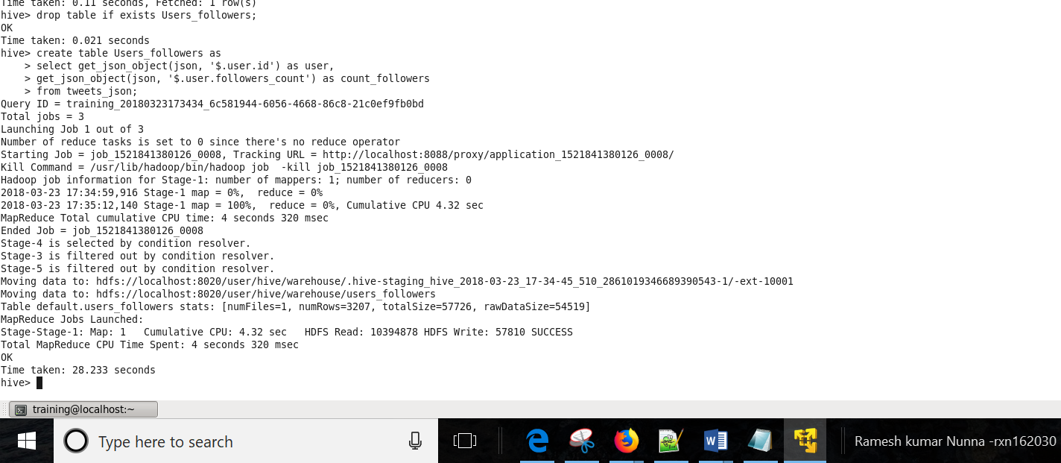

**Step 2: Creating the table and sorting users by Users_followers_count**

**Query:**

*create table Users_followers_count as SELECT user, sum(count_followers) as Users_followers_count FROM*

*Users_followers*

*GROUP BY user*

*ORDER BY Users_followers_count DESC ;*

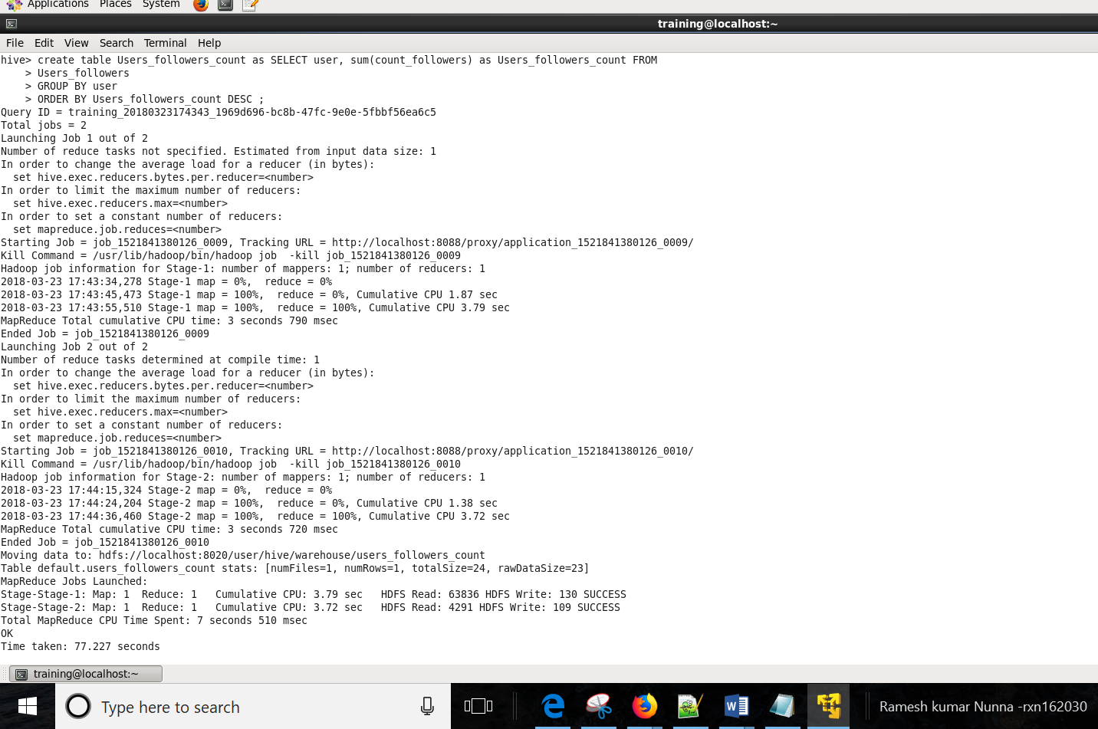

**Step 3:**

*select * from Users_followers_count;*

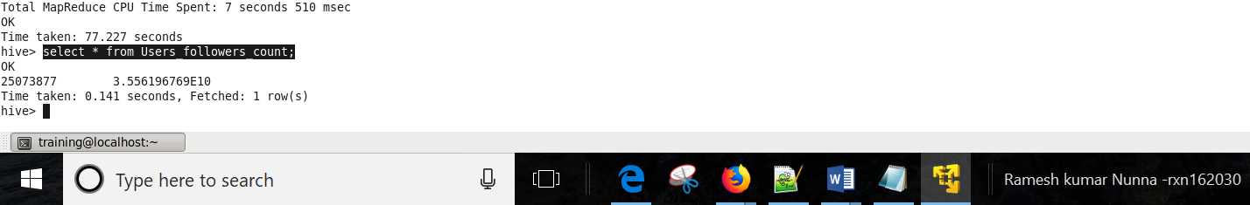

***"Donald J. Trump"(user id:* *25073877) is the only user who tweeted and he is the top user based on followers_count***

***All the tweets in the data are “Donald J. Trump” tweets and the location is "New York, NY"***

1d) What is the polarity score for each tweet that was posted? Does the tweet have a positive or negative sentiment?

a)

**Step 1: Reading JSON data**

**Query:**

*DROP table if exists data_input;*

*CREATE table data_input as SELECT get_json_object(json, '$.id') as id_tweet, get_json_object(json, '$.user.name') as user_name, get_json_object(json, '$.text') as text, unix_timestamp(get_json_object(json, '$.created_at'),'EEE MMM dd HH:mm:ss Z yyyy') as created_date*

*FROM tweets_json;*

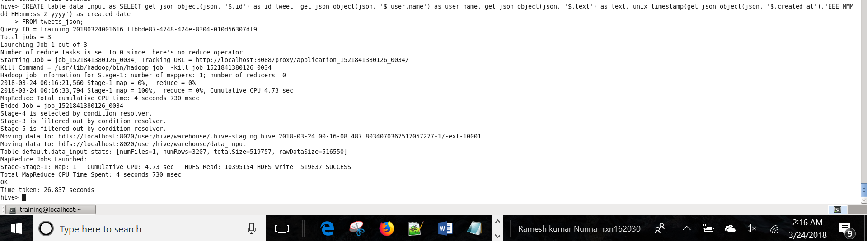

**Step 2: Splitting each tweet into words**

**Query:**

*DROP table if exists split_text;*

*CREATE table split_text as SELECT id_tweet, User_name, from_unixtime(created_date,'yyyy-MM-dd') as created_date, word FROM data_input LATERAL VIEW explode(split(text,' ')) text_ex as word;*

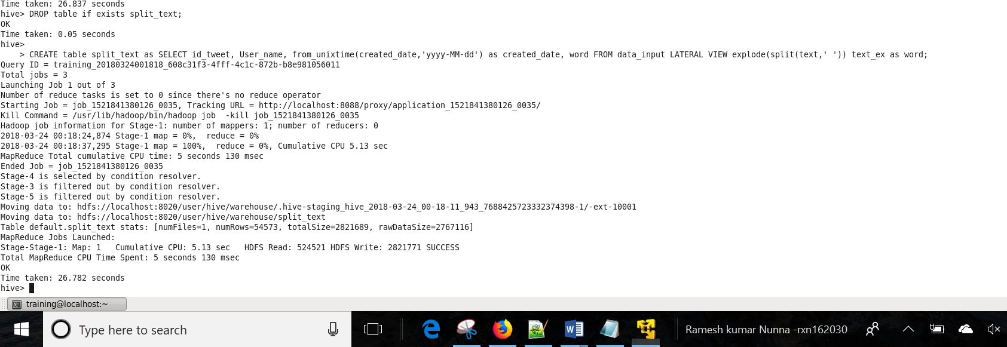

**Step 3: Importing dictionary into hive**

**Query:**

*DROP table if exists dictionary;*

*CREATE table dictionary (dictionary_word string, score string) row format delimited fields terminated by '\t';*

*load data local inpath 'Desktop/Dictionary.txt' overwrite into table dictionary;*

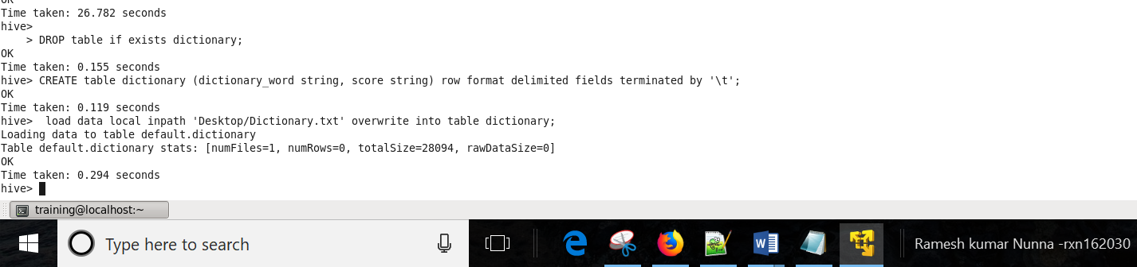

**Step 4: Joining scores from dictionary to twitter data**

**Query:**

*DROP table if exists scores_join;*

*CREATE table scores_join as SELECT a.id_tweet, a.User_name, a.created_date, a.word, d.score FROM split_text a LEFT OUTER JOIN dictionary d on (a.word = d.dictionary_word);*

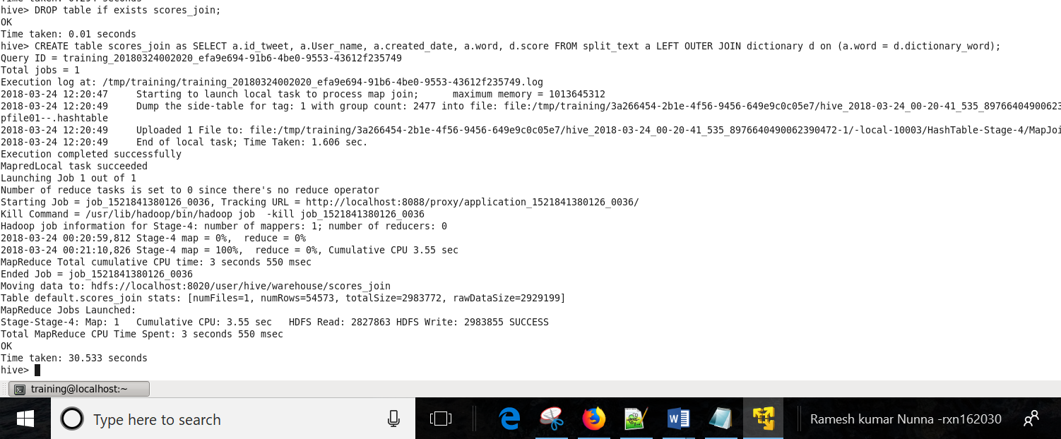

**Step 5: calculating polarity score for each tweet_id:**

**Query:**

*DROP table if exists polarity_score;*

*CREATE table polarity_score as SELECT id_tweet, User_name, created_date, sum(score) as polarity_score FROM scores_join GROUP BY id_tweet, User_name, created_date;*

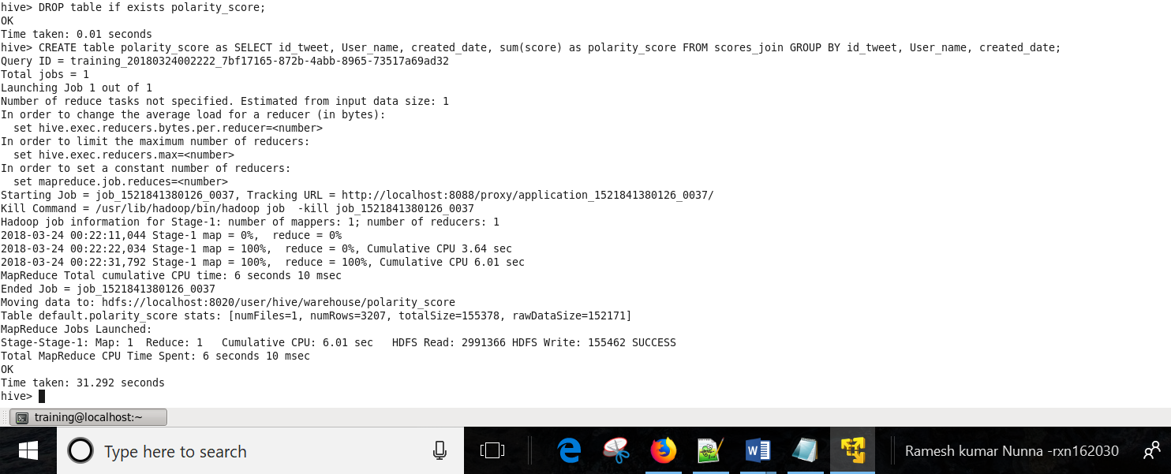

**Step 5: calculating sentiment for each tweet:**

**Query:**

*DROP table if exists tweets_sentiment_analysis;*

*CREATE table tweets_sentiment_analysis as SELECT id_tweet, User_name, created_date, polarity_score ,CASE WHEN polarity_score > 0 THEN 'Positive' WHEN polarity_score < 0 THEN 'Negative' ELSE 'None' END as tweets_sentiment_analysis FROM polarity_score;*

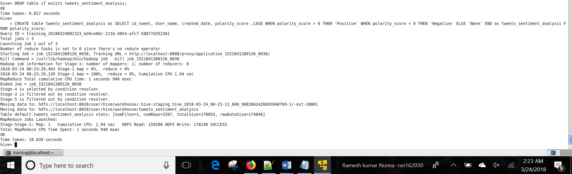

**Output: From total of 3207 tweets, the sentiment is shown for few tweets below due to space constraint.**

**Query:**

*select created_date, id_tweet,User_name,polarity_score,tweets_sentiment_analysis from tweets_sentiment_analysis;*

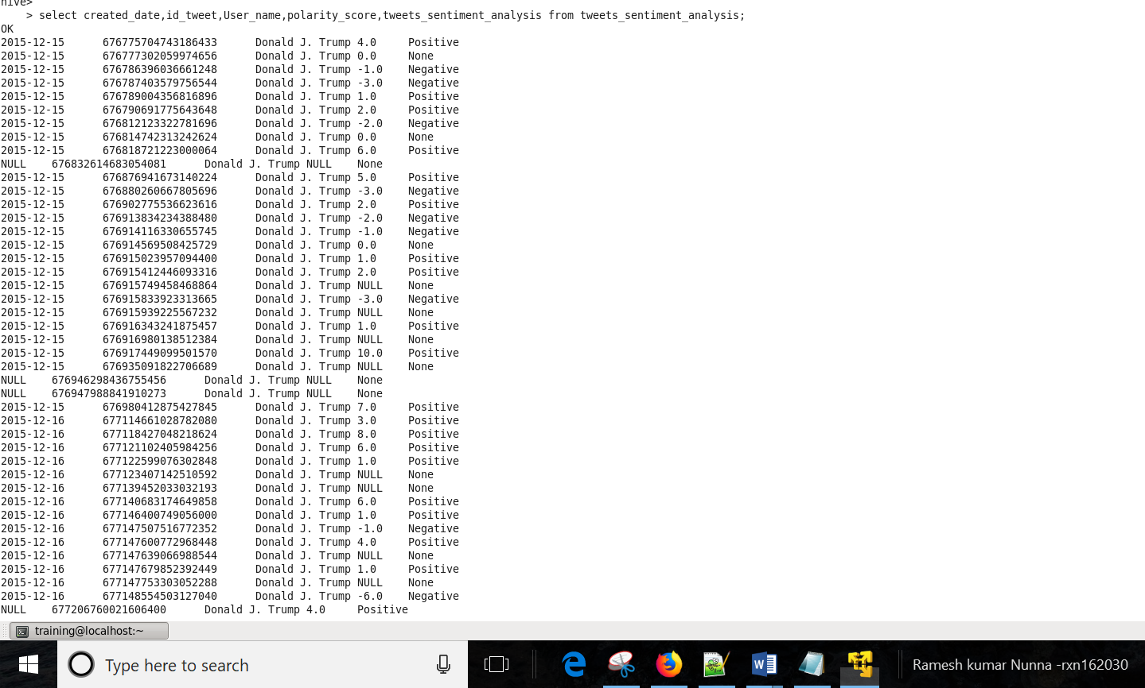

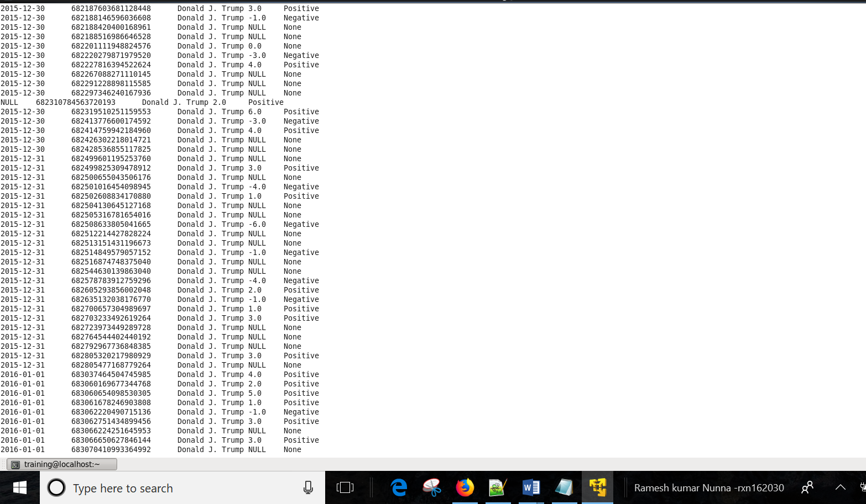

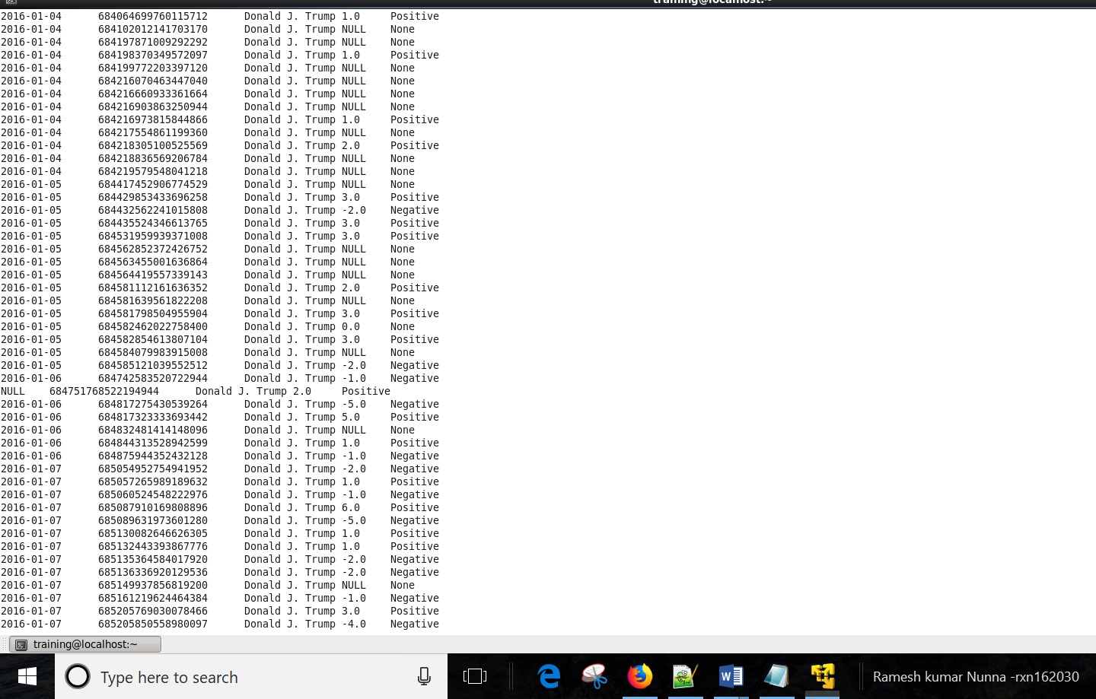

1. Do you find any problem in the way sentiment analysis was performed in the previous question? If so, how will you improve it?
2. **Problems:**
3. The analysis above is capturing sentiment based on individual words in the tweet and misses out on the overall context of the tweet (also words will have different meaning when used in phrases)
4. With sentiment analysis the tone of the writer cannot be properly analyzed whether the user tweeted in normal or in sarcastic tone.
5. The foremost problem I faced is lack of words in dictionary. Few tweets have no sentiment associated with it (null values) as they do not have corresponding words in the dictionary. Hence, the sentiment captured might not be accurate
6. The dictionary scores are very subjective. Words like compelled, bold are given positive ratings where as there can be negativity associated with it. Due to this the reason, sentiment of the tweet can be altered
7. No information on the rating scale is given (how the +5, -5 scores are decided)

**Improvements:**

1. By taking tweet context into account and using complex sentiment scoring algorithms, the process can be improved.
2. The dictionary scores should be assigned based on the connotative meaning of the word.
3. Dictionary should be made exhaustive.
4. The dictionary should be made dynamic as opposed to static nature. Dictionary scores should be updated as on the tweets generated. (based on how a word is used in the tweet context most of the times (+ve/-ve sentiment))